COMP9311 Week 02 Lecture

|  |  |
| --- | --- |
| **Assignment 1** | 1/36 |

Goal: design/implement a data model for a car dealer.

Stage 1: develop ER data model in the class

Stage 2: convert the ER model to SQL schema

|  |  |
| --- | --- |
| ER Model |  |

|  |  |
| --- | --- |
| **Exercise: Relationship Types** | 3/36 |

Describe the precise semantics of each of the following:

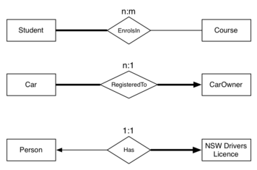

|  |  |
| --- | --- |
| **Exercise: Medical Information** | 4/36 |

Develop an ER design for the following scenario:

* Patients are identified by an SSN, and their name, address and date of birth must be recorded.
* Doctors are identified by an SSN. For each doctor, we record their name, address, specialties and year of graduation.
* A pharmacist is identified by an SSN, and we also record their name, address and qualification.
* A medical professional is either a doctor or pharmacist, but not both. Anyone can be a patient.
* For each drug, the trade name and formula must be recorded.
* Every patient has a primary physician. Every doctor has at least one patient.
* Each pharmacy has a name, address and phone number. A pharmacy must have a manager (who is a pharmacist). A pharmacist cannot work in or manage more than one pharmacy.
* Each pharmacy sells several drugs, and has a price for each. A drug could be sold at several pharmacies, and the price could vary between pharmacies.
* Doctors prescribe drugs for patients. A doctor could prescribe one or more drugs for several patients, and a patient could obtain prescriptions from several doctors. Each prescription has a date and quantity associated with it.

[[Solution]](http://www.cse.unsw.edu.au/~cs9311/16s2/lectures/week02/exercises/medicalER.html)

|  |  |
| --- | --- |
| **Exercise: Book Publishing** | 5/36 |

Develop an ER design for the following scenario:

* for each person, we need to record their tax file number (TFN), their real name, and their address
* authors write books, and may publish books using a "pen-name" (a name, different to their real name, which they use as author of books)
* editors ensure that books are written in a manner that is suitable for publication
* every editor works for just one publisher
* editors and authors have quite different skills; someone who is an editor cannot be an author, and vice versa
* a book may have several authors, just one author, or no authors (published anonymously)
* every book has one editor assigned to it, who liaises with the author(s) in getting the book ready for publication
* each book has a title, and an edition number (e.g. 1st, 2nd, 3rd)
* each published book is assigned a unique 13-digit number (its ISBN); different editions of the same book will have different ISBNs
* publishers are companies that publish (market/distribute) books
* each publisher is required to have a unique Australian business number (ABN)
* a publisher also has a name and address that need to be recorded
* a particular edition of a book is published by exactly one publisher

[[Solution]](http://www.cse.unsw.edu.au/~cs9311/16s2/lectures/week02/exercises/publishER.html)

|  |  |
| --- | --- |
| **Summary of ER** | 6/36 |

ER model is popular for doing conceptual design

* high-level, models relatively easy to understand
* good expressive power, can capture many details

Basic constructs:   *entities,   relationships,   attributes*

Relationship constraints:   *total / partial,   n:m / 1:n / 1:1*

Other constructs:   *ineritance hierarchies,   weak entities*

Many notational variants of ER exist   
(especially in the expression of constraints on relationships)

|  |  |
| --- | --- |
| Assignment 1 Stage 1 |  |

[[Spec Stage 1]](http://cgi.cse.unsw.edu.au/~cs9311/16s2/assignments/a1/index.php)

|  |  |
| --- | --- |
| **Relational Data Model** | 8/36 |

The *relational data model* describes the world as

* a collection of inter-connected *relations* (or *tables*)

Goal of relational model:

* a simple, general data modelling formalism
* which maps easily to file structures (i.e. implementable)

Relational model has two styles of terminology:

* mathematical:   relation,   tuple,   attribute,   ...
* data-oriented:   table,   record,   field/column,   ...

Warning: textbooks alternate between the two; treat them as synonyms.

|  |  |
| --- | --- |
| **... Relational Data Model** | 9/36 |

The relational model has one structuring mechanism ...

* a *relation* corresponds to a mathematical "relation"
* a *relation* can also be viewed as a "table"

Each *relation* (denoted *R,S,T,...*) has:

* a *name*   (unique within a given database)
* a set of *attributes*   (which can be viewed as column headings)

Each *attribute* (denoted *A,B,...* or *a1,a2,...*) has:

* a *name*   (unique within a given relation)
* an associated *domain*   (set of allowed values)

DB definition also uses *constraints*   (logic expressions)

|  |  |
| --- | --- |
| **... Relational Data Model** | 10/36 |

Example relation (bank accounts):

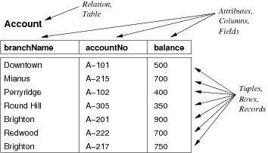

|  |  |
| --- | --- |
| **... Relational Data Model** | 11/36 |

Points to note ...

Attribute values are *atomic*   (no composite or multi-valued attributes).

A distinguished value NULL belongs to all domains.

* NULL has several interpretations: none, don't know, irrelevant

Each relation has a *key*   (subset of attributes unique for each tuple)

|  |  |
| --- | --- |
| **... Relational Data Model** | 12/36 |

Consider relation *R* with attributes *a1, a2, ... an*

*Relation schema* of *R* :   ***R****(a1:D1, a2:D2, ... an:Dn)*

*Tuple* of *R* : an element of *D1 × D2 × ... × Dn*   (i.e. list of values)

*Instance* of *R* : subset of *D1 × D2 × ... × Dn*   (i.e. set of tuples)

*Database schema* : a collection of relation schemas.

*Database (instance)* : a collection of relation instances.

|  |  |
| --- | --- |
| **DBMS Terminology** | 13/36 |

Many DBMSs have multiple namespaces:

* DBMS-level ... database names must be unique
* database-level ... schema names must be unique
* schema-level ... table names must be unique
* table-level ... attribute names must be unique

Sometimes it is convenient to use same name in several tables.

We distinguish which attribute we mean using *qualified names*

E.g. Account.branchName   vs   Branch.branchName

|  |  |
| --- | --- |
| **Example Database Schema** | 14/36 |

Schema with 4 relations:

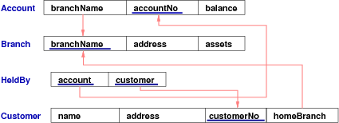

|  |  |
| --- | --- |
| **... Example Database Schema** | 15/36 |

Schema is derived from the following ER design:

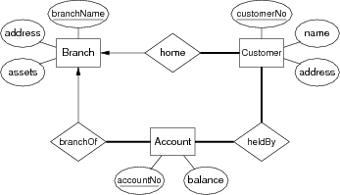

|  |  |
| --- | --- |
| **Example Database (Instance)** | 16/36 |

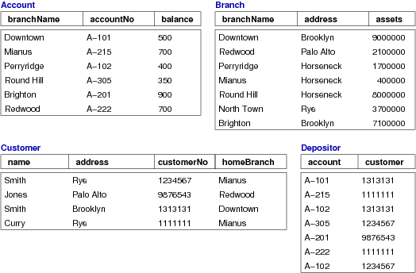

|  |  |
| --- | --- |
| **Integrity Constraints** | 17/36 |

*Relations* are used to represent entities *and* relationships.

*Domains* limit the set of values that attributes can take.

To represent real-world problems, need to describe

* what values are/are not allowed
* what combinations of values are/are not allowed

*Constraints* are logical statements that do this:

* domain, key, entity integrity, referential integrity, ...

|  |  |
| --- | --- |
| **... Integrity Constraints** | 18/36 |

*Domain constraints* example:

* Employee.age attribute is typically defined as integer
* better modelled by adding extra constraint (15<age<66)

Note: NULL satisfies all domain constraints   (except (NOT NULL))

*Key constraints* example:

* Student( id, ...) is guaranteed unique
* Class(...,day,time,location,...) is unique

*Entity integrity* example:

* Class(...,Mon,2pm,Lyre,...) is well-defined
* Class(...,**NULL**,2pm,Lyre,...) is not well-defined

|  |  |
| --- | --- |
| **Referential Integrity** | 19/36 |

*Referential integrity constraints*

* describe references between relations (tables)
* are related to notion of a *foreign key* (FK)

Example:

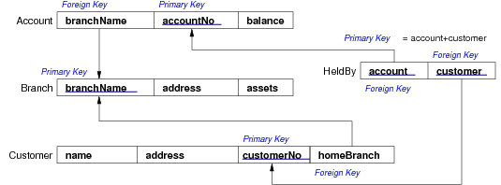

|  |  |
| --- | --- |
| **... Referential Integrity** | 20/36 |

A set of attributes *F* in relation *R1* is a *foreign key* for *R2* if:

* the attributes in *F* correspond to the primary key of *R2*
* the value for *F* in each tuple of *R1*
  + either   occurs as a primary key in *R2*
  + or   is entirely NULL

Foreign keys are critical in relational DBs; they provide ...

* the "glue" that links individual relations (tables)
* the way to assemble query answers from multiple tables
* the relational representation of ER relationships

|  |  |
| --- | --- |
| **Relational Databases** | 21/36 |

A *relational database schema* is

* a set of relation schemas   *{ R1,   R2,  ...  Rn }* ,   and
* a set of integrity constraints

A *relational database instance* is

* a set of relation instances   *{ r1(R1),   r2(R2),  ...  rn(Rn) }*
* where all of the integrity constraints are satisfied

One of the important functions of a relational DBMS:

* ensure that all data in the database satisfies constraints

|  |  |
| --- | --- |
| **Describing Relational Schemas** | 22/36 |

We need a formalism to express relational schemas   
(which is more detailed than boxes-and-arrows diagrams used above)

SQL provides a *D*ata *D*efinition *L*anguage (DDL) for this.

**CREATE TABLE** *TableName* **(**

*attrName1* *domain1* *constraints1* **,**

*attrName2* *domain2* *constraints2* **,**

...

**PRIMARY KEY** (*attri*,*attrj*,...)

**FOREIGN KEY** (*attrx*,*attry*,...)

**REFERENCES**

*OtherTable* (*attrm*,*attrn*,...)

**);**

|  |  |
| --- | --- |
| **SQL Syntax in a Nutshell** | 23/36 |

Comments: everything after **--** *is a comment*

Identifiers: alphanumeric (a la C), but also "An Identifier"

Reserved words: many e.g. CREATE, SELECT, TABLE, ...

Strings: e.g. 'a string',  'don''t ask',  but no '\n'

Numbers: like C, e.g. 1,  -5,  3.14159,  ...

Identifiers and reserved words are case-insensitive:   
TableName = tablename = TaBLeNamE != "TableName"

Types:  integer,  float,  char(*n*),  varchar(*n*),  date, ...

Operators:  =,  <>,  <,  <=,  >,  >=,  AND,  OR,  NOT, ...

|  |  |
| --- | --- |
| **Exercise: Simple Relational Schema** | 24/36 |

Express the following schema in SQL DDL:



Assume only two domains: text and integer.

[[Solution]](http://www.cse.unsw.edu.au/~cs9311/16s2/lectures/week02/exercises/bank.sql)

|  |  |
| --- | --- |
| **... Exercise: Simple Relational Schema** | 25/36 |

Augment the previous schema to enforce:

* no accounts can be overdrawn
* customer numbers are seven-digit integers
* account numbers look like A-101, B-306, etc.
* the assets of a branch is the sum of the balances in all of the accounts held at that branch

Assume that all standard SQL types (domains) are available.

Add new domain to define account numbers and use it throughout

|  |  |
| --- | --- |
| Mapping ER Designs to Relational Schemas |  |

|  |  |
| --- | --- |
| **ER to Relational Mapping** | 27/36 |

One useful strategy for database design:

* perform initial data modelling using ER or OO   
  (conceptual-level modelling)
* transform conceptual design into relational model   
  (implementation-level modelling)

A formal mapping exists for ER model *→* Relational model.

This maps "structures"; but additional info is needed, e.g.

* concrete domains for attributes and other constraints

|  |  |
| --- | --- |
| **Relational Model vs ER Model** | 28/36 |

Correspondences between relational and ER data models:

* attribute(ER) *≅* attribute(Rel),  entity(ER) *≅* tuple(Rel)
* entity set(ER) *≅* relation(Rel),  relationship(ER) *≅* relation(Rel)

Differences between relational and ER models:

* Rel uses relations to model entities *and* relationships
* Rel has no composite or multi-valued attributes (only atomic)
* Rel has no object-oriented notions (e.g. subclasses, inheritance)

|  |  |
| --- | --- |
| **Mapping Strong Entities** | 29/36 |

An entity set *E* with atomic attributes *a1, a2, ... an*

maps to

A relation *R* with attributes (columns) *a1, a2, ... an*

Example:

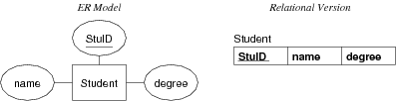

Note: the key is preserved in the mapping.

|  |  |
| --- | --- |
| **Mapping Weak Entities** | 30/36 |

Example:

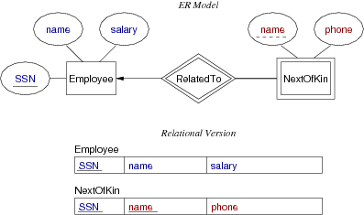

|  |  |
| --- | --- |
| **Mapping N:M Relationships** | 31/36 |

Example:

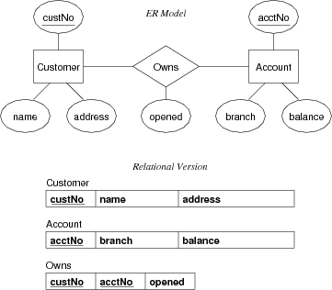

|  |  |
| --- | --- |
| **Mapping 1:N Relationships** | 32/36 |

Example:

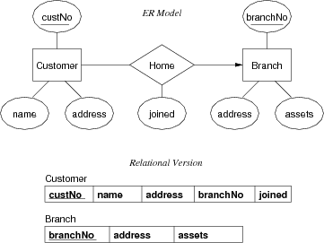

|  |  |
| --- | --- |
| **Exercise: ER-to-Relational (1)** | 33/36 |

Convert this ER design to relational form:

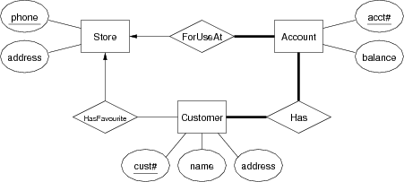

[[Solution]](http://www.cse.unsw.edu.au/~cs9311/16s2/lectures/week02/exercises/shopping.sql)

|  |  |
| --- | --- |
| **Mapping 1:1 Relationships** | 34/36 |

Example #1:

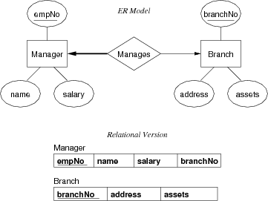

|  |  |
| --- | --- |
| **... Mapping 1:1 Relationships** | 35/36 |

Example #2:

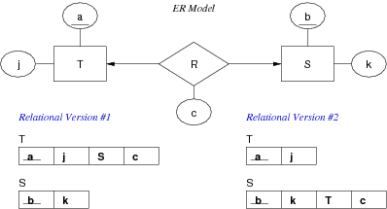

|  |  |
| --- | --- |
| **Exercise: ER-to-Relational (2)** | 36/36 |

Convert this ER design to relational form:

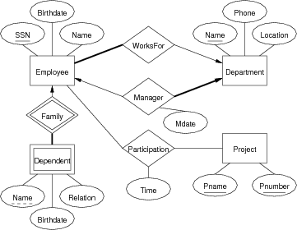

[[Solution]](http://www.cse.unsw.edu.au/~cs9311/16s2/lectures/week02/exercises/empproj.sql)

Produced: 2 Aug 2016